|  |  |
| --- | --- |
| **Logo - Club Logo copy**  Breakfast Chatter  2016 | C:\Users\arasmussen\Downloads\images.jpg |

##### The Weekly Bulletin of Rotary Club of Kathmandu Mid-Town Celebrating 26 Years of Rotary

##### April is the month of Maternal and Child Health

# Weekly Meetings and Programmes:

|  |  |  |
| --- | --- | --- |
| Date | Speaker | Program/Topics of Presentation |
| 1 April |  | Club Assembly, please do not bring guests |
| 25 February | Chang Agrawal | Director Himalaya TV |
|  |  |  |

|  |  |  |
| --- | --- | --- |
| Club News | | |
|  |  |  |

|  |  |  |  |  |
| --- | --- | --- | --- | --- |
| Mr. Agrawal’s talk highlighted the creative aspects of the Himalayan TV. He showed us a few series of video clips done by Himalayan TV in an attempt to raise consciousness and highlight the plight of the general Nepali population together with an attempt at the collection of heart-breaking stories narrated by the storytellers themselves.C:\Users\arasmussen\AppData\Local\Microsoft\Windows\INetCache\Content.Outlook\CBTFF60Q\IMG_0803.JPG | | | Treasurer Shyam Thapaliya gave the vote of thanks.  C:\Users\arasmussen\AppData\Local\Microsoft\Windows\INetCache\Content.Outlook\CBTFF60Q\IMG_0805.JPG | C:\Users\arasmussen\AppData\Local\Microsoft\Windows\INetCache\Content.Outlook\CBTFF60Q\IMG_0808.JPGand President Paras Rana handed over the appreciation letter after the presentation. |
|  |  |

|  |  |
| --- | --- |
| C:\Users\arasmussen\AppData\Local\Microsoft\Windows\INetCache\Content.Outlook\CBTFF60Q\IMG_0811.JPG  ANM representatives from Humla attended the meeting and gave a short update on the current state and achievements of the birthing centre | The Spouse Club is organising a Picnic on 9 April 2016 at a fantastic location - said to be a winery at the outskirts Kathmandu valley.  It might be opportune to encourage this event.  For those who were not present at the last meeting to sign up there will be a sign up sheet this Friday too.  The cost is Rs. 1500 per person.  Thank you in advance for your kind support.  The idea of establishingPataleban Vineyard Resortcame up with the influence of winery resorts in Japan. The company was registered in 2006 in Nepal affiliated to NICHIBI KAIKAN of Tokyo, Japan. The objective of the company is to develop eco-tourism, horticulture and organic farming.    The Resort site lies 16km. west of Kathmandu city at an altitude of 1600m. It covers an area of 2 hector facing north west at Chisapani Village, Baadbhanjyang VDC. 5, Kathmandu, Nepal. It is surrounded by a community forest known as Pataleban, have great views of sunset, the Himalayan range of Langtang, Ganesh, Manaslu, Annapurna and the Valley of Dhading. |

|  |
| --- |
| Rotary Quote of the Week |

Rotary President-elect John Germ shares his rules for leadership and success. <http://on.rotary.org/1QJzqlJ>



|  |  |
| --- | --- |
|  |  |

# Rotary International News

From the[*March 2016 issue*](https://www.rotary.org/myrotary/en/node/228186)ofThe Rotarian

When John Germ takes office as Rotary International’s president in July, it will mark his 40th year in Rotary. In that time, he’s likely best-known for leading Rotary’s $200 Million Challenge, a fundraising effort sparked by a challenge grant from the Bill & Melinda Gates Foundation. Rotarians surpassed that goal in 2011, raising $228.7 million toward polio immunization activities. “I never questioned that we would raise the funds,” he says. “Rotarians have been so generous.” In fact, raising money for polio was one of Germ’s first leadership roles. He became a member of the Rotary Club of Chattanooga, Tenn., in 1976. “I wasn’t involved, other than going to meetings, until 1983 when I was asked to be club secretary,” he says. “Then I was asked to participate as district co-chair for the polio fundraising campaign.” After that, he was hooked. “The more active I became, and the more good that I saw being done, the more I wanted to do,” he says. Germ went on to serve Rotary as vice president, director, Foundation trustee and vice chair, and RI president’s aide. He and his wife, Judy, are also members of the Arch Klumph Society. Professionally, Germ continues to consult for Campbell & Associates, a Chattanooga engineering firm he started working for in 1965 and eventually served as chairman and CEO. Editor in Chief John Rezek spoke with him about his next big commitment – his yearlong role as RI president.

**Register for the International Convention in Korea**

### **Connect with thought leaders**

Hear from [exceptional speakers](http://www.riconvention.org/en/seoul/speakers) including RI President K.R. Ravindran and other Rotary senior leaders, who will educate and inspire you.

**31 March 2016:** Preregistration discount ends  
**30 April 2016:** Registration/ticket cancellation deadline  
**1 June 2016:** Online registration ends; deadline for cancellations due to visa denial.

### Calendar:

31 March — Preregistration discount ends for [Rotary International Convention](http://www.riconvention.org/)

1 April — Deadline to report activities to earn a Presidential Citation for [Rotary](https://www.rotary.org/myrotary/en/news-media/office-president/presidential-citation-rotary-clubs) and [Rotaract clubs](https://www.rotary.org/myrotary/en/news-media/office-president/presidential-citation-rotaract-clubs)

10-15 April — [Council on Legislation](https://www.rotary.org/myrotary/en/exchange-ideas/events/council-legislation)

15 April — Deadline to report activities to earn a Presidential Citation for [Interact clubs](https://www.rotary.org/myrotary/en/news-media/office-president/presidential-citation-interact-clubs)

*30 A*pril — Registration/ticket cancellation deadline for [Rotary International Convention](http://www.riconvention.org/)

### Please update your ‘My Rotary’ Account

First go to www.rotary.org.

Then **click on My Rotary**. And then **Click on Sign In/Register**.

If you are a first time user, click on **Create account.**

Fill in the Account registration information **and click on Continue.**

You will be informed that an e-mail has been sent to you.

Check your email for the address you provided in the step above. You will receive a message from Rotary. Click on the blue link in the mail to finalize the process.

# A Thought for the Day:

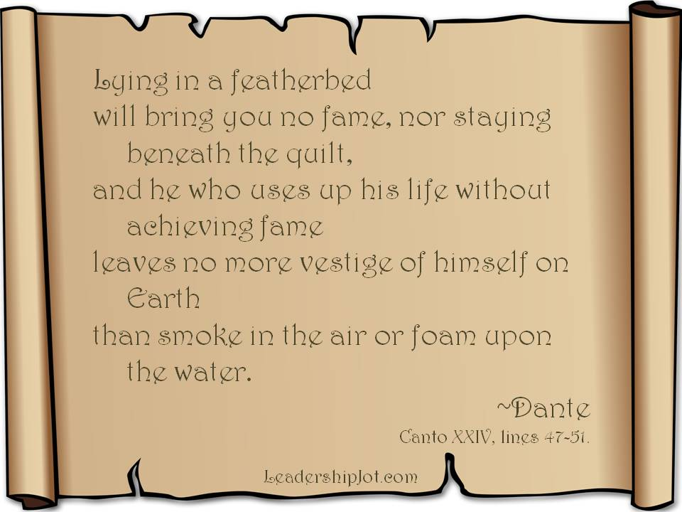

### Nepali holidays in April

|  |  |  |
| --- | --- | --- |
| 13 Apr | Wed | Nepali New Year |
| 15 Apr | Fri | Ram Nawami Ram Navami falls on the ninth day of the Hindu lunar year (thus named Chaitra Masa Suklapaksha Navami). Rama Nawami is a Hindu festival, celebrating the birth of the god Rama to King Dasharatha and Queen Kausalya in Ayodhya. Rama, the seventh avatar of Vishnu, is one of the oldest avatars of Lord Vishnu having a human form. |
| 23 Apr | Sat | Loktantra Diwas (Democracy Day) |

## NB: Send any information/photos that may be of interest to the Club or Rotarians in general to

## BC Editor: Anja M. Rasmussen, email: anjamrasmussen@gmail.com

#### **District : 3292** We**b:** www.rotarymidtown.org.np **Club Id : 26776**

#### Facebook: <https://www.facebook.com/RotaryClubOfKathmanduMidtown>

Venue: Fridays at 7:30AM, Hotel de l'Annapurna, Kathmandu, NEPAL